Weston Forbes



Tyrannosaurus Plex

KEYENCE / PLEX Transfer Utility

# Introduction

Tyrannosaurus Plex is a program that transfers data between Keyence Optical Comparators and PLEX SPC check sheets. It accomplishes this by reading data from the Keyence CSV files and then simulating a user to type the values into PLEX. Once recipes are setup, all the user needs to do is select the recipe and press a button.

The recipe setup process is also designed to be as “pain-free” as possible.

# Injecting Data Into a SPC Checksheet

|  |  |
| --- | --- |
| International Symbol Labels - General Warning | This section assumes the desired recipe has already been set up. If the desired recipe does not exist, see Recipe Setup. |

# Recipe Setup

# Interface

## Main Screen

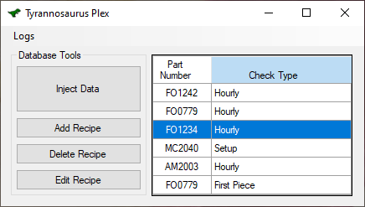

Figure - Main Screen

### Parts

* “Inject Data” Button – This is the button that the end user will use most of the time. It starts the process of moving data from the Keyence system over to the PLEX SPC check sheet.
* “Add Recipe” Button – This button allows users to add new recipes to Tyrannosaurus Plex.
* “Delete Recipe” Button – This button allows users to delete recipes from Tyrannosaurus Plex.
* “Edit Recipe” Button – This button allows users to edit recipes that currently exist in the Tyrannosaurus Plex Database.
* Selection Window – This is where a user selects the recipe they want to use.
* “Logs” Button – This is for troubleshooting. It brings up a display of all that is happening on the back-end of Tyrannosaurus Plex.

## Add / Edit Recipe Screen

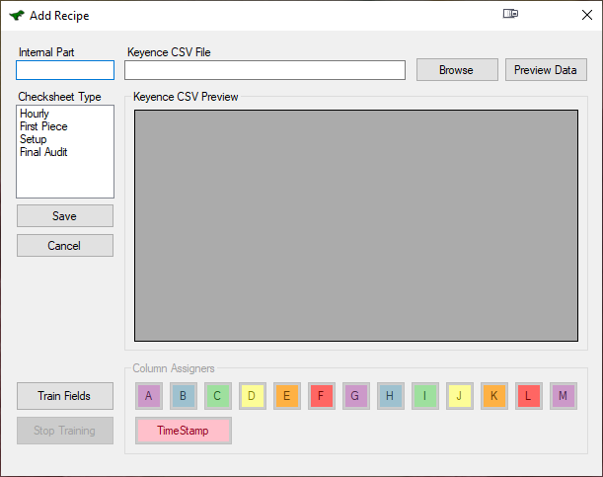

### Parts

* “Internal Part” Field – Required for recipe to save. ASPCs internal part number.
* “Checksheet Type” List – Users must select what type of check sheet the recipe is. If new types need to be added, see the maintenance section.
* “Save” Button – Saves the recipe and closes the window.
* “Cancel” Button – Closes the window without saving.
* “Train Fields” Button – This button activates the key logger for recording key sequences. This is detailed in the Add / Edit recipe section.
* “Stop Training” Button – This button stops the key logging process.
* “Keyence CSV File” Field – This holds the location of the target csv file. It may be typed in or set through the “Browse” button.
* “Browse” Button – Opens an OpenFile Dialog for selecting CSV file.
* “Preview Data” Button – Refreshes the file data in the “Keyence CSV Preview” Window.
* “Keyence CSV Preview” Window – Shows the data from the CSV file.
* “Column Assigners” – These buttons flag the currently selected column in the “Keyence CSV Preview” window. This is detailed in more depth in the Add/Edit recipes section.